Turner Duncan
10/30/2017
STAT 555 Project Proposal

The goal of my proposed project is to determine possible errors in RNA-Seq differential expression analysis when different qualities (High Quality vs Lower Quality) of reference genome is used in the RNA-Seq analysis pipeline. I would perform this project using two different Zebra Finch (Taeniopygia guttata) genomes 1) a high quality Long Read Reference Assembly (LRR) and a lower quality Short Read Reference assembly. The details of two reference assemblies I would use are below:

- Long Read Reference (LRR)
  - Tgut_diploid_1.0 (Pacific Biosciences)
  - https://www.ncbi.nlm.nih.gov/assembly/GCF_000151805.1
Total sequence length | 1,982,686,095
Total assembly gap length | 0
Number of contigs | 3,347
Contig N50 | 4,297,012
Contig L50 | 119

- Short Read Reference (SRR)
  - Taeniopygia_guttata-3.2.4 (Washington University)
  - https://www.ncbi.nlm.nih.gov/assembly/GCF_000151805.1
Total sequence length | 1,232,135,591
Total assembly gap length | 9,270,900
Number of contigs | 124,806
Contig N50 | 38,639
Contig L50 | 8,016

It has been shown in recently published work that the most recent LRR for the Zebra Finch is ~150 fold more contiguous than the previous SRR.
https://academic.oup.com/gigascience/article/doi/10.1093/gigascience/gix085/4096262/De-Novo-PacBio-long-read-and-phased-avian-genome#97710651

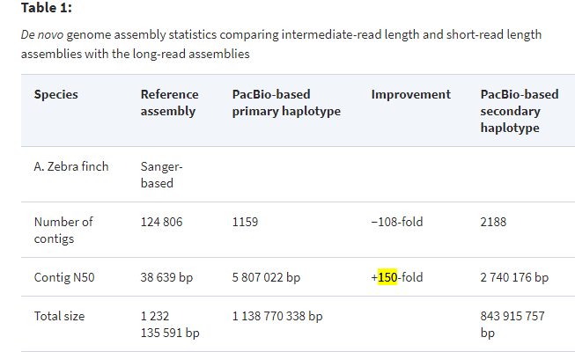

Additionally the LRR used the PacBio Iso-Seq (full length isoform) method instead of Illumina based RNA-Seq for transcriptome annotation and found 5.2% more isoforms than the previous reference genome.
http://www.pacb.com/wp-content/uploads/Vierra-G10K-2017-From-RNA-to-Full-Length-Transcripts-1.pdf
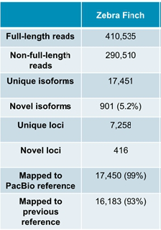
Given the greatly improved Zebra Finch reference is a recent release (Oct 1, 2017). I imagine anyone who performed a differential expression analysis with Zebra Finch as a model organism prior to Oct 1, 2017 would get different results because they used a significantly inferior SRR reference for the mapping step of their RNA-Seq analysis. I would like to quantify the different results one would get..

To examine this I propose to use data from the publication Transcriptional response to West Nile virus infection in the zebra finch (Taeniopygia guttata) that performed differential expression analysis using the SRR genome as a reference for the mapping step of RNA-Seq analysis. For my project I will reproduce parts of this publication using the SRR assembly as well as perform novel differential expression comparisons using the newly released LRR assembly as a mapping step for RNA-Seq analysis.

In this publication they compare differential transcript expression of female Taeniopygia guttata individuals with West Nile Virus (WNV) as a control and at 4 days post infection by performing an Illumina RNA-Seq data on a HiSeq2500 using paired 2x100bp transcriptiomic cDNA. The samples for this project can be downloaded on SRA:
- Sample 1 – Control SRR5001851
  - https://www.ncbi.nlm.nih.gov/biosample/SAMN05981661
- Sample 2 - Control SRR5001848
  - https://www.ncbi.nlm.nih.gov/biosample/SAMN05981662
- Sample 3 – Control SRR5001850
  - https://www.ncbi.nlm.nih.gov/biosample/SAMN05981663
- Sample 1 - 4 Days Post Infection (DPI) SRR5001844
  - https://www.ncbi.nlm.nih.gov/biosample/SAMN05981679
- Sample 2 - 4 Days Post Infection (DPI) SRR5001847
  - https://www.ncbi.nlm.nih.gov/biosample/SAMN05981680
- Sample 3 - 4 Days Post Infection (DPI) SRR5001846
  - https://www.ncbi.nlm.nih.gov/biosample/SAMN05981681

The pipeline I propose to get expression data for each sample is:
- Alignment via hisat2
- Quantification via featureCounts
- Differential expression via DESeq2

I learned this pipeline in a previous class and I have the computation power/knowledge to run the alignments for each sample. https://www.biostarhandbook.com/rnaseq/rnaseq-griffith-control.html

The Differential Expression comparisons I plan make are outlined below. One of them is the same DE analysis that is in the previously published paper, however the other three are new comparisons that I am making. I should be able to reproduce the first comparison below. The other comparisons will allow me to characterize the genes that differentially express between using different qualities of reference genomes.

- SRR Control vs SRR Infected
  - (This would be the same as Control vs 4DPI in the previously published paper and would show that my scripts are correct)
- LRR Control vs LRR Infected
  - (This would be unique to my project)
- SRR vs LRR
  - (This is one I am doing differently and would show which genes are differentially expressed between SRR and LRR reference genomes)
- Control vs Infected
  - (This would be unique to my project)

I should also be able to compare the % of reads that map to each reference genome for each sample using TopHat2. Here I would expect a higher % of reads to map to the LRR assembly compared to the SRR assembly.

